**DAILY ONLINE ACTIVITIES SUMMARY**

|  |  |  |  |  |  |  |  |  |
| --- | --- | --- | --- | --- | --- | --- | --- | --- |
| **Date:** | **09-6-2020** | | | | | **Name:** | **Likhitha.M** | |
| **Sem & Sec** | **6th sem ‘A’** | | | | | **USN:** | **4al17cs046** | |
| **Online Test Summary** | | | | | | | | |
| **Subject** | | **Computer Graphics and Visualization**  **Cryptography, Network Security and Cyber Law** | | | | | | |
| **Max. Marks** | | **30**  **60** | | **Score** | | | **25**  **47** | |
| **Certification Course Summary** | | | | | | | | |
| **Course** | **Introduction to Ethical Hacking** | | | | | | | |
| **Certificate Provider** | | | **Great learning** | | **Duration** | | | **3 days** |
| **Coding Challenges** | | | | | | | | |
| **Problem Statement:**  1. Write a C++ Program to rotate the matrix by K times.  2.Write a Python to implement Perfect Sum Problem  Given an array arr[] of integers and an integer K, the task is to print all subsets of the given array with the sum equal to the given target K.  Input: arr[] = {5, 10, 12, 13, 15, 18}, K = 30  Output: {12, 18}, {5, 12, 13}, {5, 10, 15}  Explanation: Subsets with sum 30 are: 12 + 18 = 30 5 + 12 + 13 = 30 5 + 10 + 15 = 30  3.Python Program to count even and odd numbers  Write a Python program to count the number of even and odd numbers from a series of numbers.  4. write a java Program to print smallest and biggest possible palindrome word in a given string  5. Write a Java Program to remove all white spaces from a string without using replace() | | | | | | | | |
| **Status: completed** | | | | | | | | |
| **Uploaded the report in Github** | | | | | **yes** | | | |
| **If yes Repository name** | | | | | **https://github.com/likhithaMantaral/Daily-status** | | | |
| **Uploaded the report in slack** | | | | | **yes** | | | |

Online test Details:

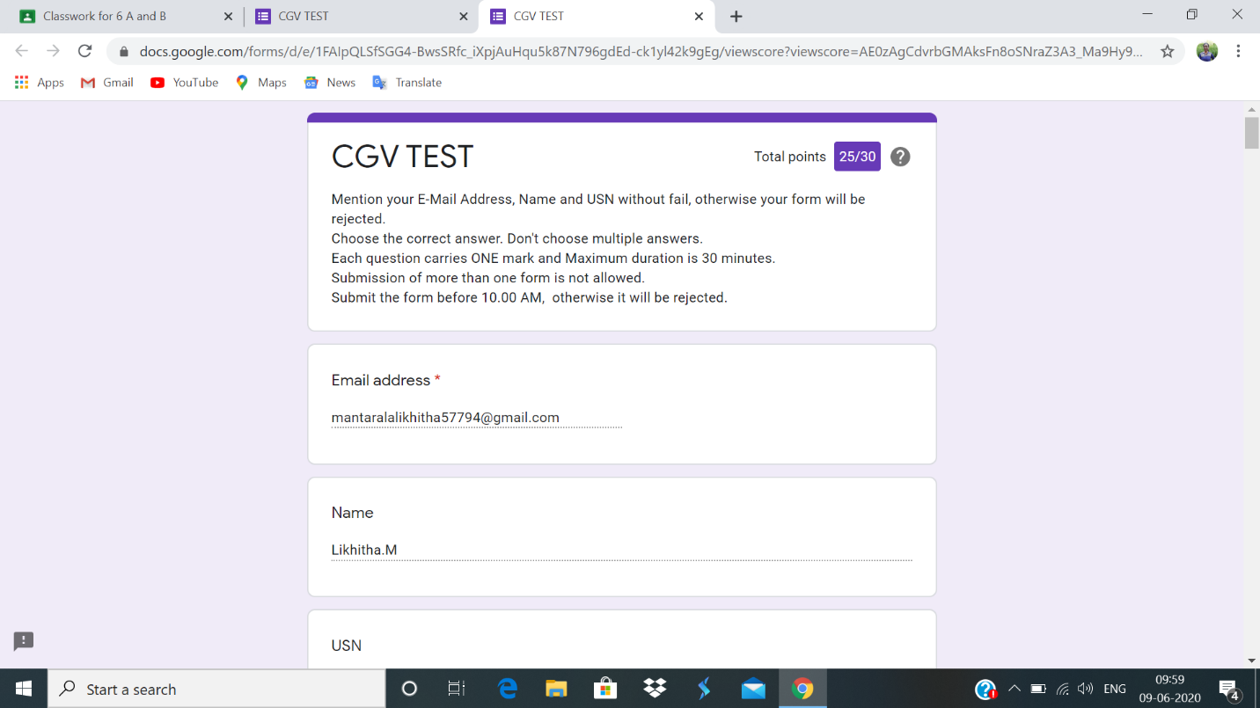

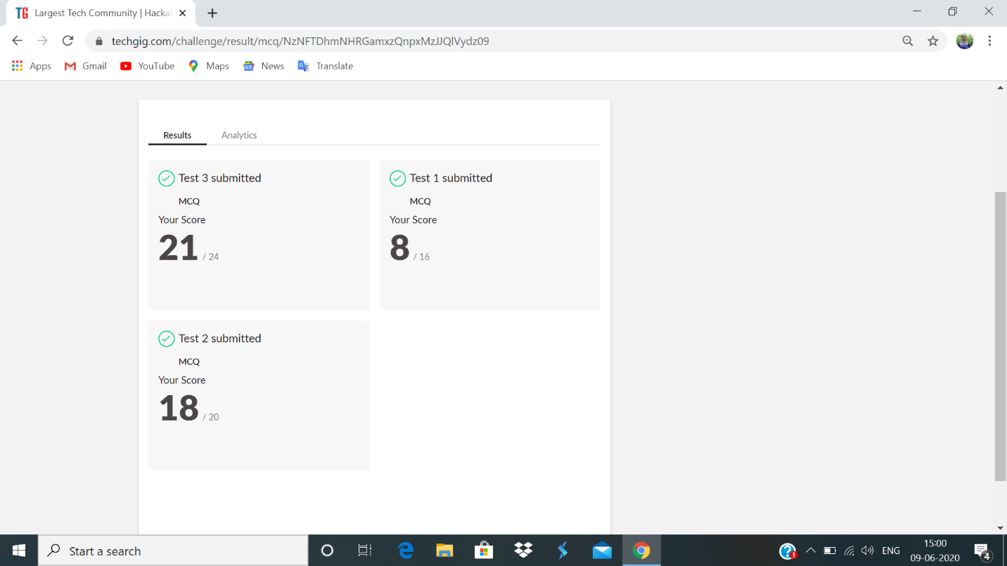

Certification Course Details:

**Ethical Hacking in Network Architecture- Demonstration**

Agenda-

1. OSI model 2. TCL/IP 3. Top 10 tools Network security 4. way Handshake 5.Metasploit Framework and Architecture 6.Demonstration.

The career landscape and array of opportunities in the field of Ethical hacking, Penetration Testing and other correlated professions will be covered in detail. 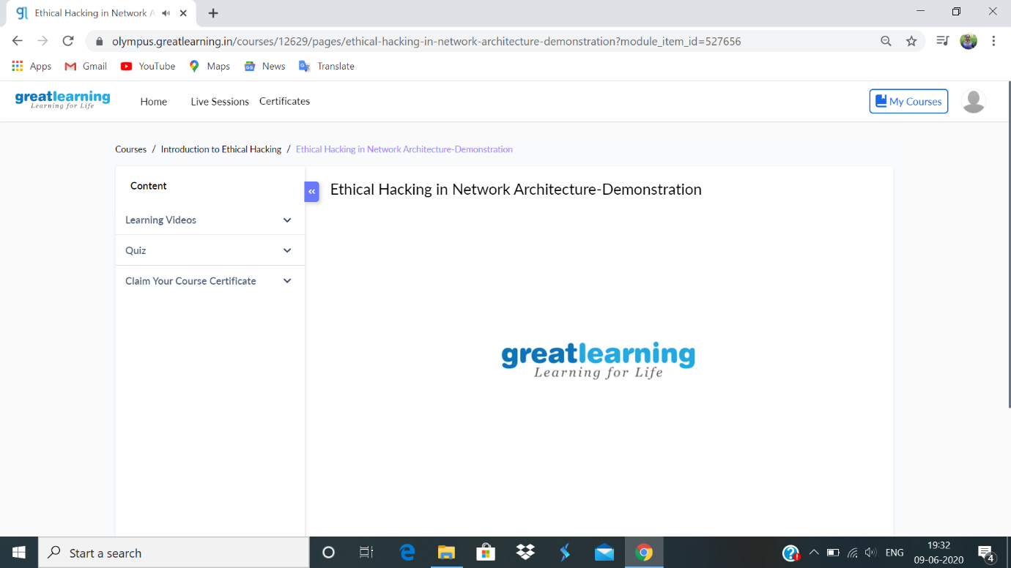

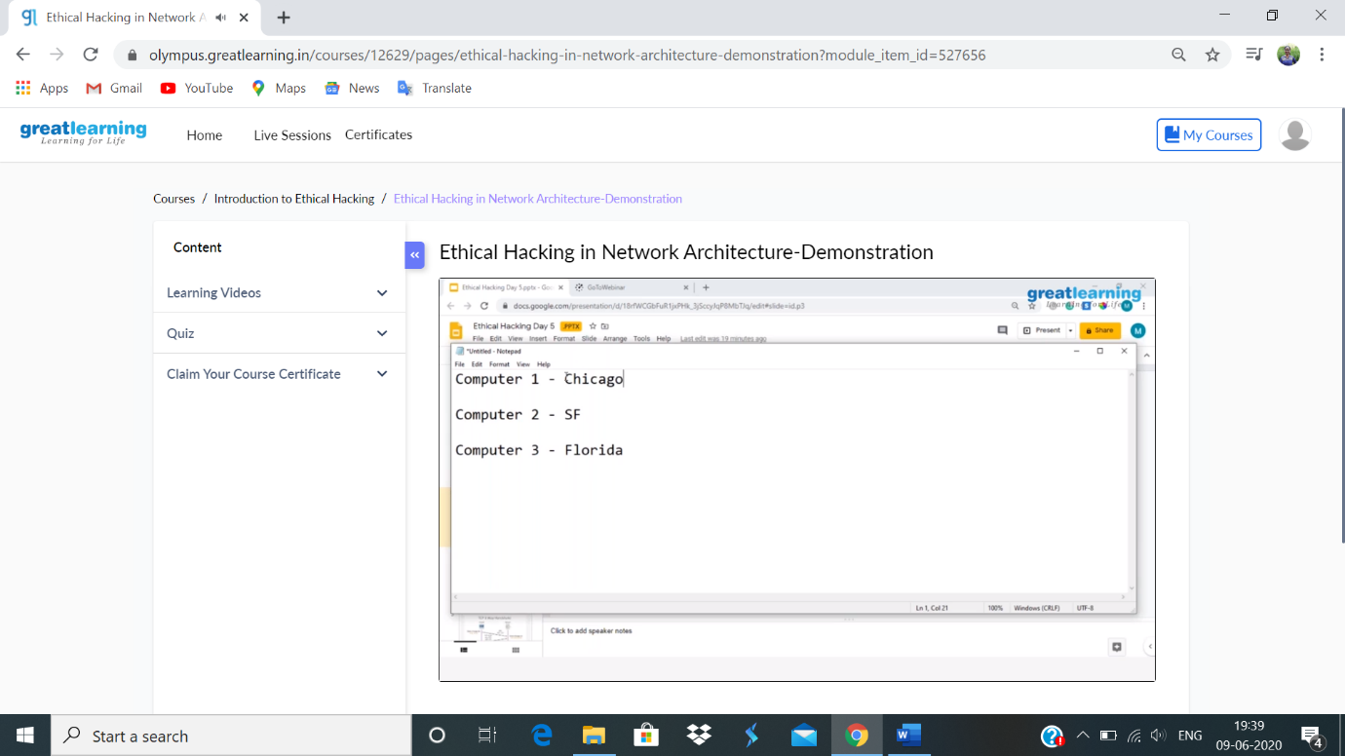

**Coding challenge:**

**1.**

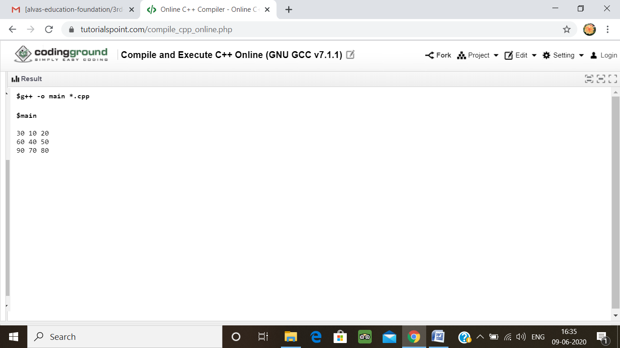

2.

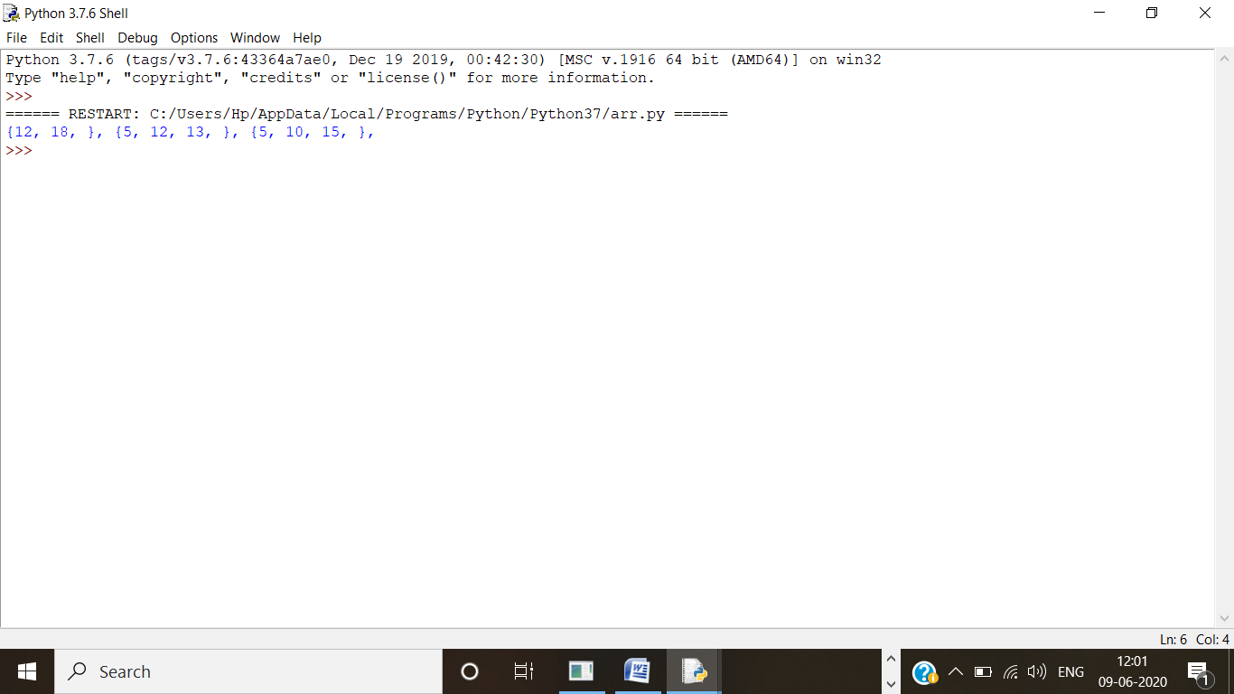

3.

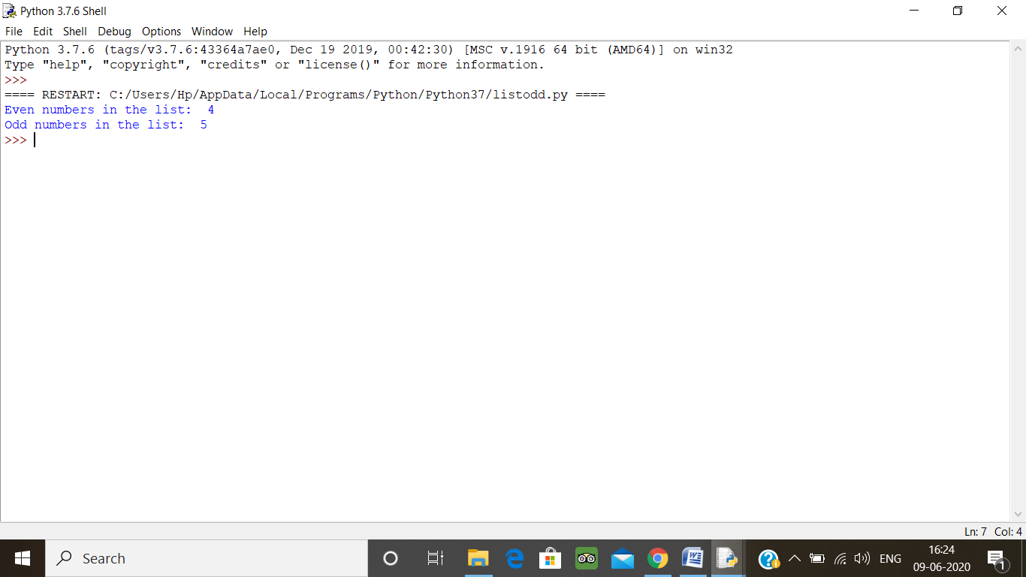

4.

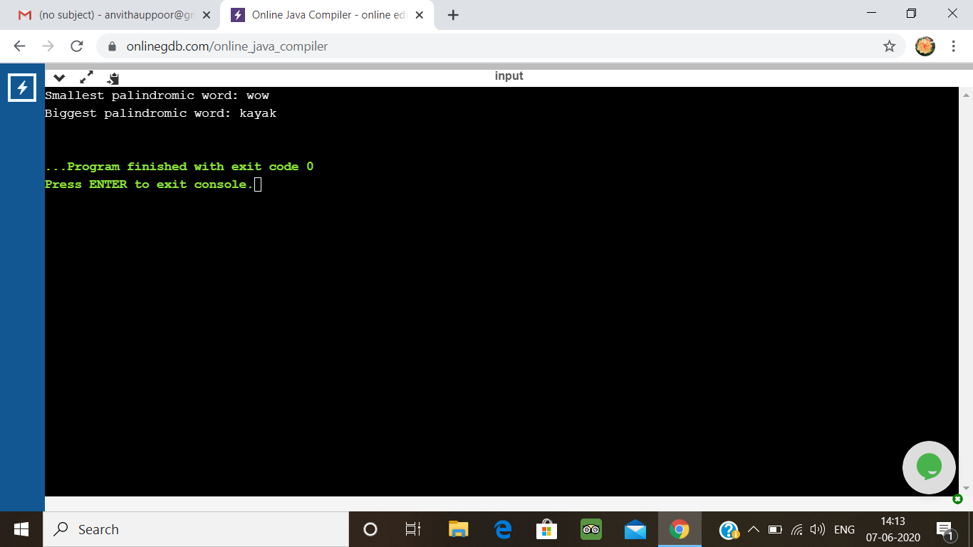

5.

